**Experiment No. 5**

**Title: Numerical Aperture and attenuation in optical fibre**

**Aim:** To determine the Numerical Aperture and attenuation in an optical fibre

*Numerical Aperture*

**Theoretical Background:**

Acceptance angle is defined as the maximum angle that a light ray can make with the axis of the fiber and propagate along with it. It is given by

# 𝜃 ∴ 𝑁𝐴 = 𝑠𝑖𝑛𝜃

Numerical aperture is defined as the sine of the acceptance angle.

Where, fractional refractive index is

𝑛1 − 𝑛2

∆ =

# 𝑛1

The output cone of light is identical to the input cone, as shown in Fig. 1.

RMS intermodal dispersion is given by

# ∆ 1 𝐿 (𝑁𝐴)2

(

∆

𝑡

)

𝑠

~

𝐿

𝑛

1

2

√

3

𝑐

~

𝐿

(

𝑁𝐴

)

2

4

√

3

𝑛

1

𝑐

=

4

√

3

∙

∙

𝑛

1

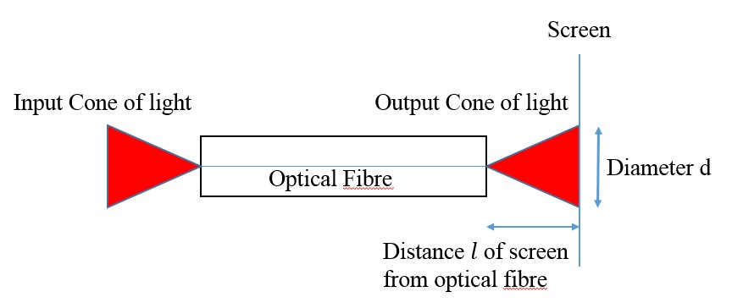

𝑐

**Fig. 1** Input and output cones of light for an optical fibre

**Design of the experiment:**

The output cone is intercepted by a graph sheet at various distances (Fig. 2) to get circles of light (Fig. 3)

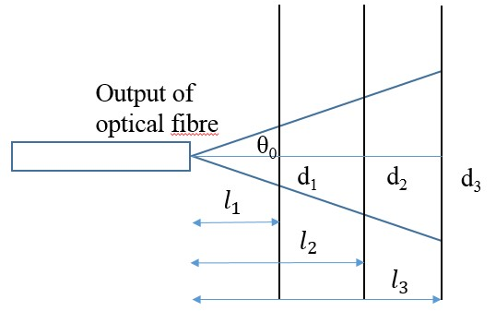

**Fig. 2** The output cone of light intercepts the screen at distances 𝑙1, 𝑙2, 𝑙3, etc. giving rise to circles of light with diameters d1, d2, d3, etc**.**

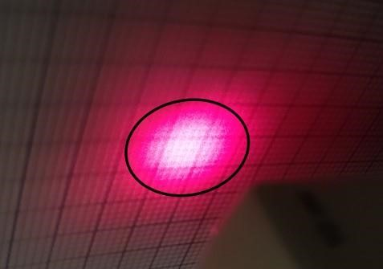

**Fig. 3** A typical circular pattern of light on a graph sheet. The circle is shown schematically to define the diameter of the circular light pattern on the screen.

From Fig. 2

# 𝑑𝑛+1 − 𝑑𝑛

𝑡𝑎𝑛𝜃0 = 2(𝑙𝑛+1 − 𝑙𝑛)

The diameters dn of the circles on the screen are plotted as a function of the distance 𝑙𝑛 of the screen from the output of the optical fibre. The value of 𝑡𝑎𝑛𝜃0 is then equal to half the slope. Calculate 𝜃0 and NA=sin 𝜃0. Since the cladding is air, n2 = 1. Calculate n1, Δ, (∆𝑡) 𝑠 and 𝐵𝑚𝑎𝑥.

*Attenuation*

**Theoretical Background**

If the input optical power launched into an optical fibre is 𝑃𝑖 and the output power is 𝑃𝑜, then attenuation is defined in decibels (dB) as

𝑃𝑖

𝐴𝑡𝑡𝑒𝑛𝑢𝑎𝑡𝑖𝑜𝑛 𝐴(𝑑𝐵) = 10𝑙𝑜𝑔10 ()

𝑃𝑜

Fibre loss parameter 𝛼𝑑𝐵, which represents signal attenuation per unit length in dB, is defined as

𝑃𝑖

𝛼𝑑𝐵𝐿 = 10𝑙𝑜𝑔10 ( )

# 𝑃𝑜

**Definition of dBm**

When the input power is assumed to be 1mW, the units of comparison of a given power is in dBm.

𝑃(𝑚𝑊)

∴ 𝑃(𝑑𝐵𝑚) = 10𝑙𝑜𝑔10 () 𝑑𝐵𝑚

# 1𝑚𝑊 𝑑𝐵𝑚

For example, if the output power is 100μW, then the output power is

**Design of the experiment:**

An optical power meter is used to measure the attenuation in three fibres of 1m, 3m and 10m length. A red LED emitting a wavelength 6500Å is coupled to an optical fibre with a core diameter of 1mm and the cladding is air. The light output from the optical fibre is measured using the optical power meter in the units of dBm.

Plot output power in dBm as a function of the length of the fibre. The slope will give attenuation in dB/m and the intercept will give the power of the source of light in dBm.

**Observation Tables**

Wavelength of the light: 6500 Å

**Table 1:** Diameter circle of light from the output cone of light for an optical fibre for various distances of the screen from the output of the optical fibre

|  |  |
| --- | --- |
| distance 𝑙 (mm) | diameter (mm) |
| 20 | 300 |
| 30 | 380 |
| 40 | 440 |
| 50 | 520 |
| 60 | 600 |
| 70 | 700 |
| 80 | 800 |

**Table 2:** Power in dBm at the output of optical fibres of various lengths

|  |  |
| --- | --- |
| length L (m) | Power (dBm) |
| 1 | -37.90 |
| 3 | -41.82 |
| 10 | -44.79 |

**Calculations:**

*Numerical Aperture:*

Plot diameter d versus distance 𝑙 in Excel. Add a linear trend line (*y=mx+c*) and display the equation.

𝑡𝑎𝑛𝜃0 = m/2= 4.10715

Acceptance angle 𝜃0 = 𝑡𝑎𝑛−1 (𝑚2 ) = 76.32 deg

Numerical Aperture 𝑁𝐴 = 𝑠𝑖𝑛(𝜃0) = 0.796676491

𝑁𝐴 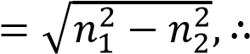 𝑁𝐴2 = 𝑛12 − 𝑛22

# 𝑛12 = 𝑁𝐴2 + 𝑛22

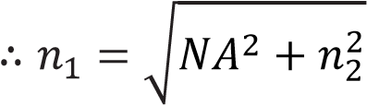

= 1.278551

Fractional refractive index

𝑛1 − 𝑛2

∆ =

𝑛1

= 0.217865

Intermodal dispersion

1 𝐿 (𝑁𝐴)2

(∆𝑡)𝑠 = ∙ ∙

# 4√3 𝑐 𝑛1

= 2.38838E-08

# 𝐵𝑚𝑎𝑥 = 0.2/(𝛥𝑡)𝑠 𝑏𝑖𝑡𝑠/𝑠𝑒𝑐

= 8373866.331

=8.37 Mbps

for optical fibre length *L* = 100m.

*Attenuation*

Plot Power(dBm) versus length(m) of the optical fibre in Excel. Add a linear (*y=mx+c*) trend line and display the equation.

Fibre loss parameter 𝛼𝑑𝐵 = −𝑚 in units of dB/m. = 0.6764

Attenuation for an optical fibre of length L (= 100meters) is *A*(*dB*) =(𝛼𝑑𝐵 × 100 )𝑑𝐵

= 67.64

The intercept “c” is the power of the source of light 𝑃𝑖 in dBm . Therefore, power of the source (or input power Pi) in mW is

𝑃𝑖(𝑚𝑊) = 10^((𝑃𝑖(𝑑𝐵𝑚)/10)

= 0.000146319

Attenuation *A*(*dB*) after traveling a distance of L is

# 𝐴(𝑑𝐵) = 10𝑙𝑜𝑔10 (Pi/ P0)

Therefore, output power

𝑃0 = 𝑃𝑖10^(-A/10)

**=** 2.51942E-11

**Results:**

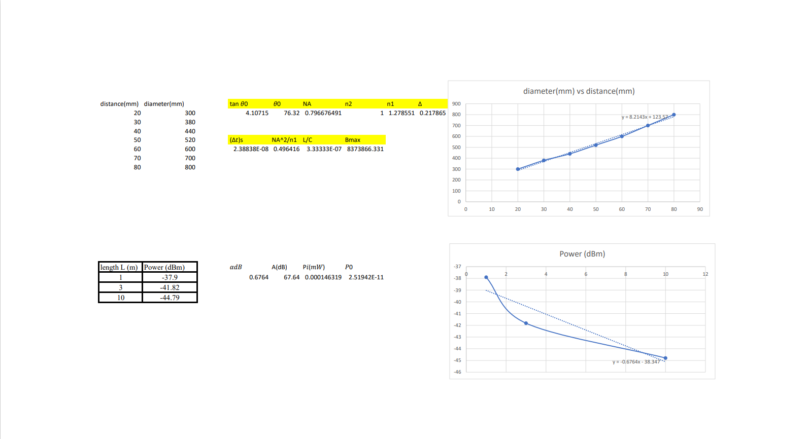

**Conclusion:** We determined Numerical aperture and attenuation in optical fibre.